**Name : Omkar pralhad Gharat**

**Enrollment No : 2101950**

**Sub : Cloud Computing Practical-1**

**\*\*\*\*\*\*\*\*\*\*\*\*\*\*\*\*\*\*\*\*\*\*\*\*\*\*\*\*\*\*\*\*\*\*\*\*\*\*\*\*\*\*\*\*\*\*\*\*\*\*\*\*\*\*\***

**Launch EC2 Instance(windows)- AWS Platform**

**\*\*\*\*\*\*\*\*\*\*\*\*\*\*\*\*\*\*\*\*\*\*\*\*\*\*\*\*\*\*\*\*\*\*\*\*\*\*\*\*\*\*\*\*\*\*\*\*\*\*\*\*\*\*\***

**Step-1: Login into AWS student Login**

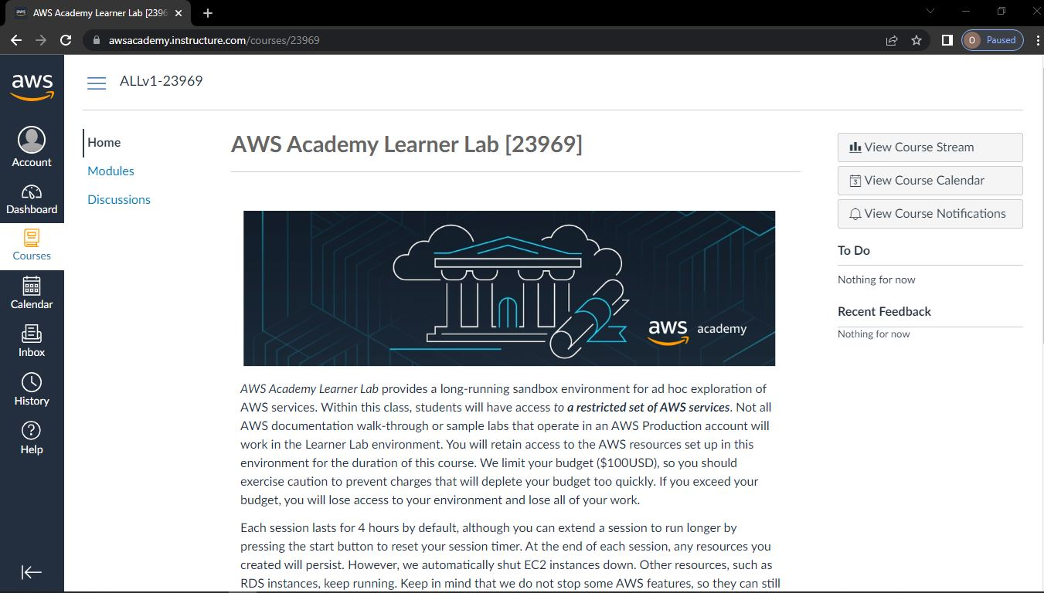

**Step-2: Click on Module**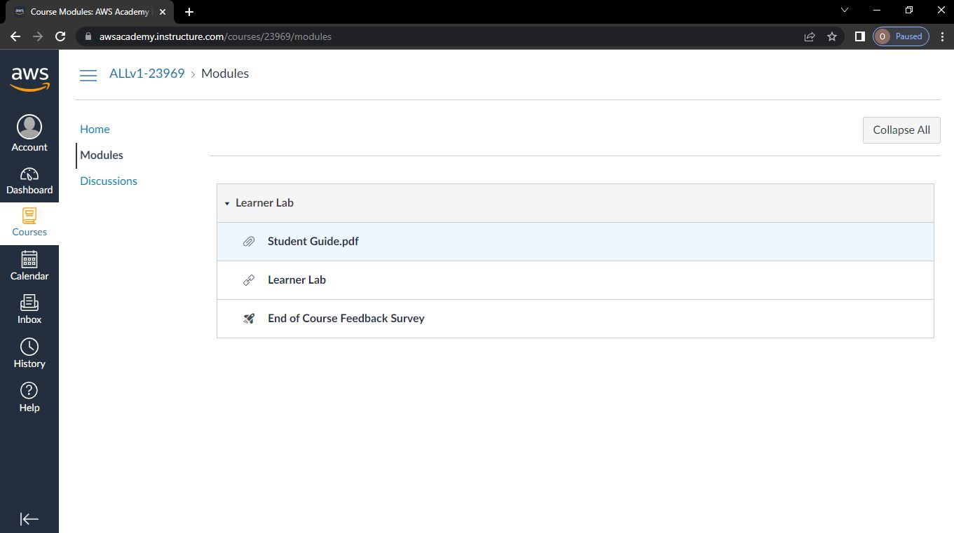

**Step-3: Using a Learner Lab   
To start the lab, you have to click on Start Lab.**

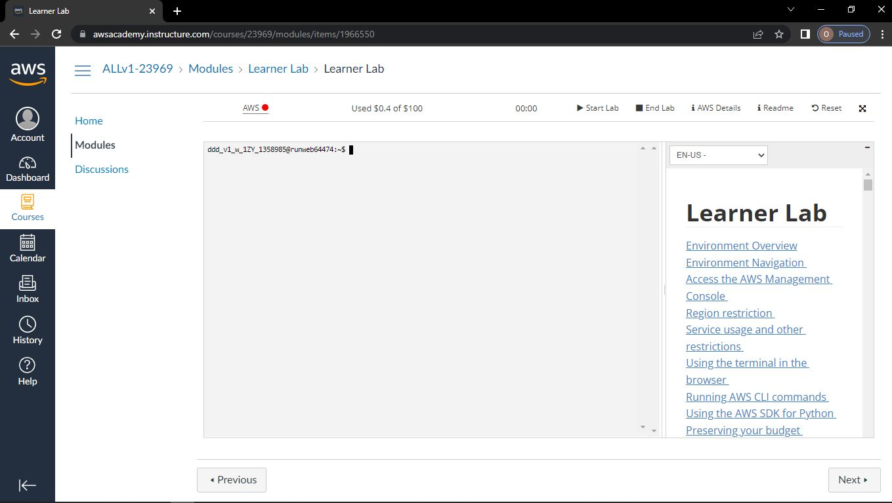

**Step-4: After clicking learner Lab then you have to click on start lab**

**Wait until AWS is changes to green**

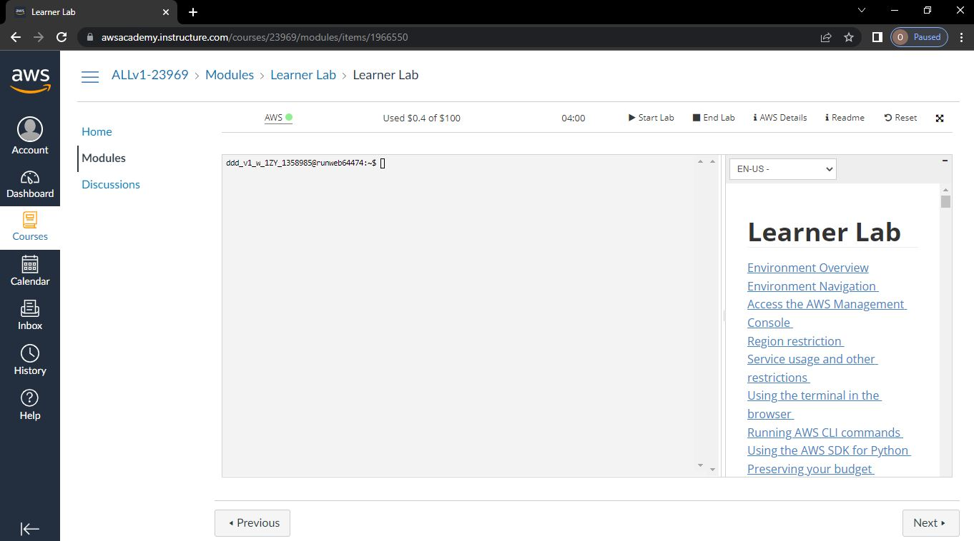

**Step-5: Then click on AWS**

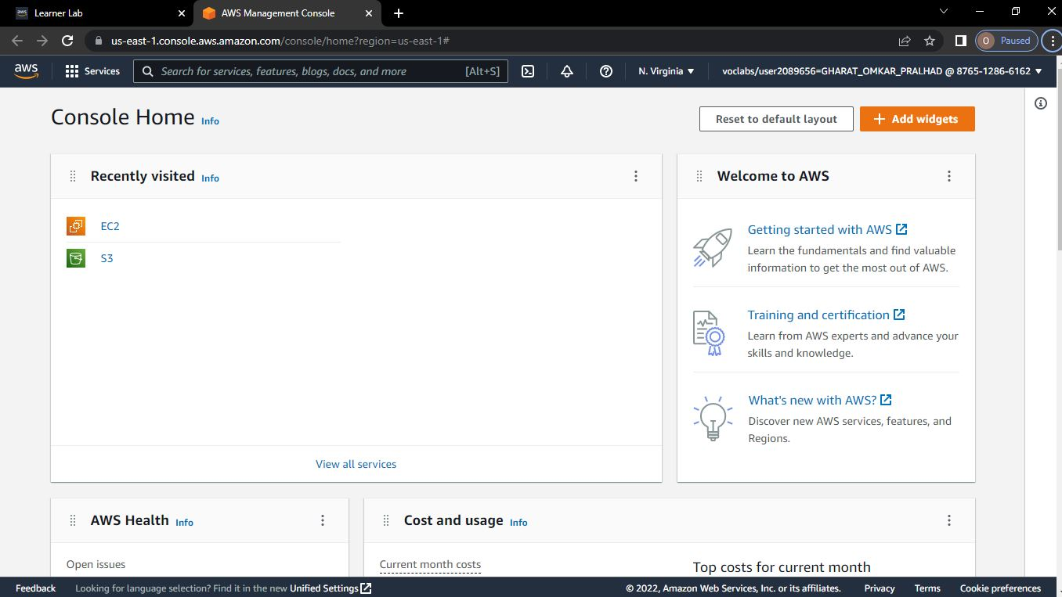

**Step-6: Click on services**

**Under services click on compute**

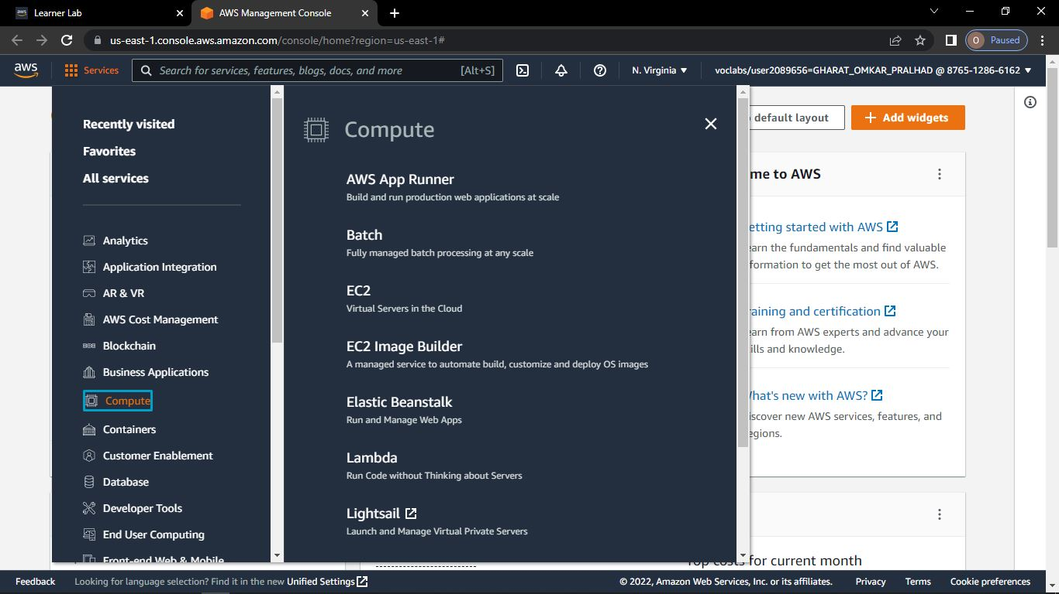

**Step-7: Click on EC2**

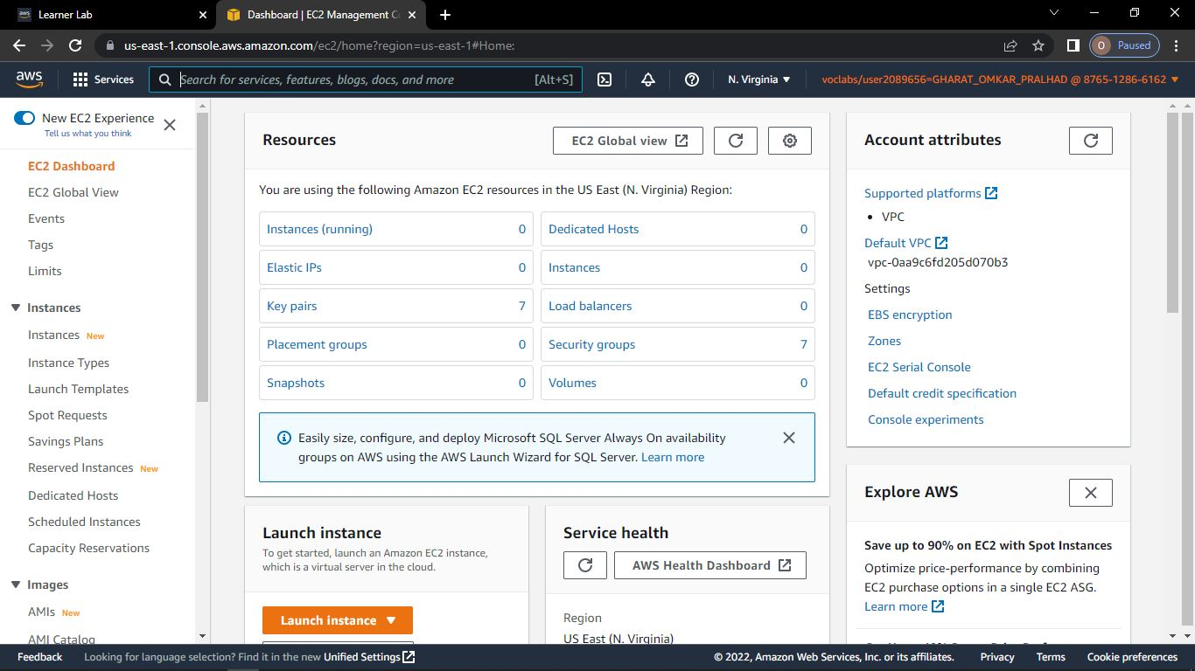

**Step-8: Click on launch instance**

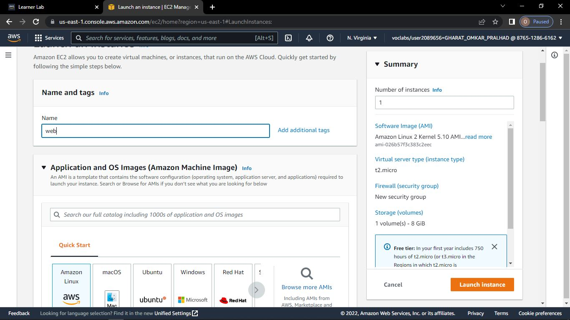

**Step-9: In key pair login**

**Click on create new key pair & Give the name of key pair and click on Create Key Pair**

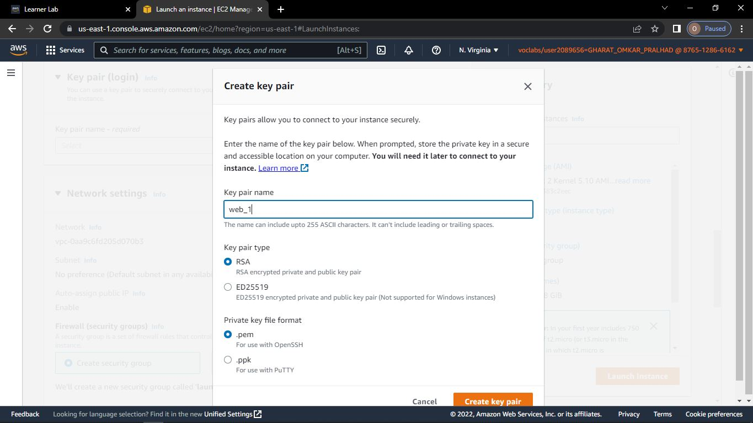

**Step-10: Click on Launch Instance**

**Wait until it gets successfully launched and Click on View all instances**

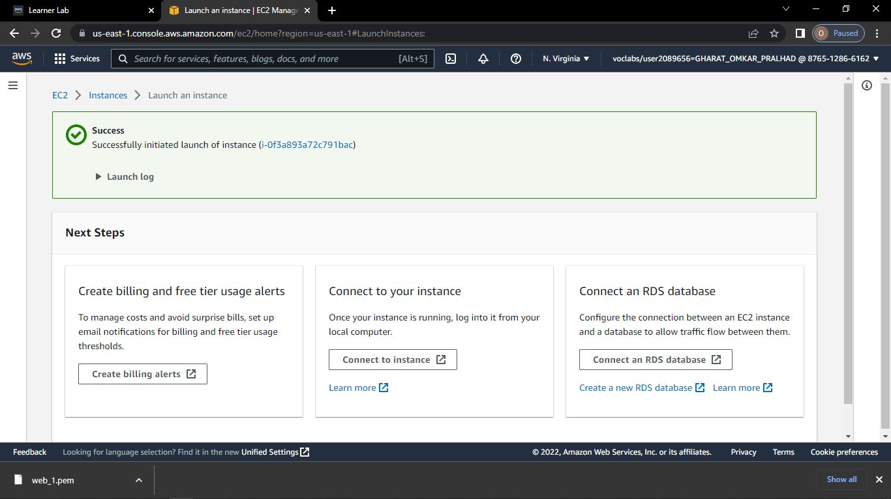

**Step-11: Click on Connect**

**Click on RDP client and download remote desktop file**

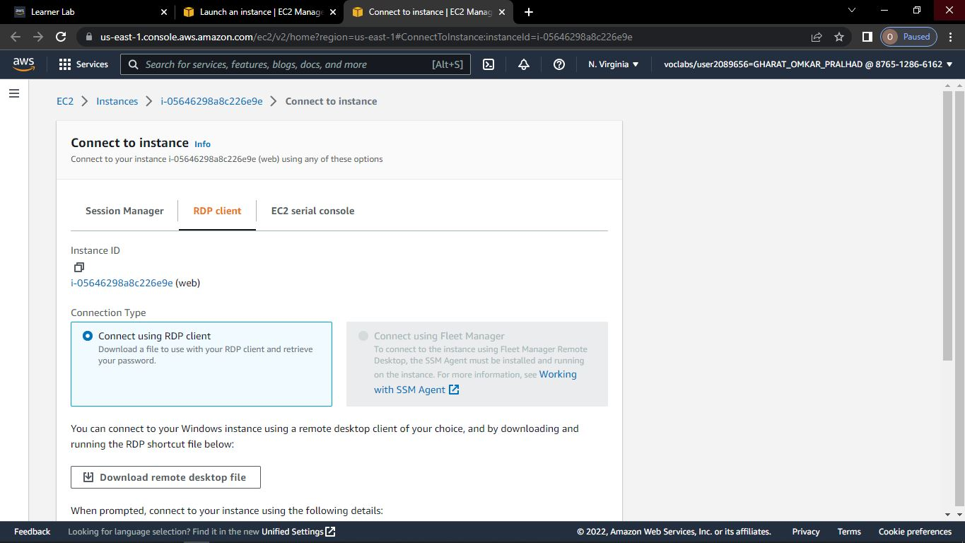

**Step-12: Click on Get password**

**Click on browse and select the file that we have downloaded and click on Decrypt password**

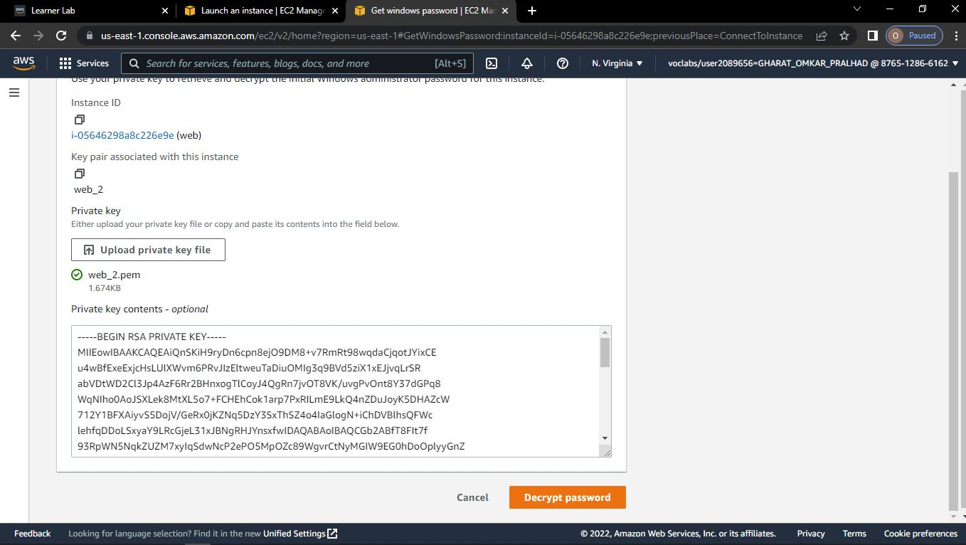

**Step-13: Click on instance state and below that click on terminate instance.**

**Click on terminate**

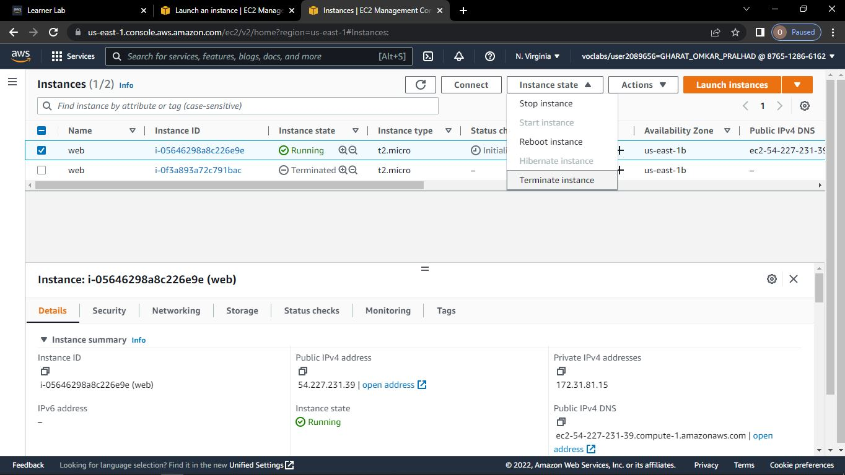

**Step-14: When you are finished with the session, choose End Lab.**



